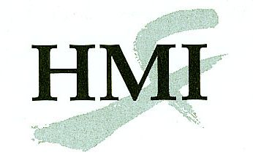
Medical Acupuncture for Physicians
Chinese Scalp Acupuncture Course Application
Tempe, AZ
26-27 May 2012

Complete this form onscreen, then print and send it with all the required documents by mail or fax, or save and email this form and the documents to:
Helms Medical Institute
2520 Milvia Street
Berkeley, CA 94704
Fax: 510-649-8692
E-mail: mafp@hmieducation.com

The fee for this course is $750 through 26 April 2012 and $800 from 27 April to 25 May 2012.

Name:
First Initial Last

Degree:
MD, DO, DDS, DPM, DMD

State Medical License #:

Specialty:

E-mail:

Street:
Street address only, no P.O. boxes

City:

State: |  | Zip:_

Day Phone:

Home Phone:

Cell Phone:

Fax:
Please use the format 555-555-5555.

Year completed basic HMI Course:

Payment:
If paying with a check, make it payable to Helms Medical Institute.

Card Number:
Discover, MasterCard, or Visa only.
Expiration Date: |  | /
Month Year

Cardholder’s Name:

Authorizing Signature:

Date: |  | / |  | /

Month Day Year

All training activities will take place at the Tempe Mission Palms Hotel, Tempe, Arizona, 15 minutes from Phoenix Sky Harbor International Airport. You are requested to lodge at the hotel where a group rate of $159 has been arranged. A conference day use fee of $75 is required of participants who choose to stay elsewhere, or who choose to share a room with another course participant.
For additional information concerning this program call 510-649-8488 or e-mail mafp@HMIeducation.com. This program is limited to 50 participants. Please apply early.

