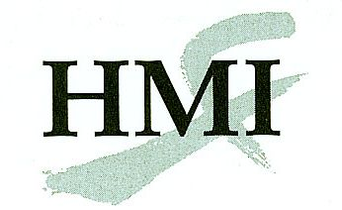
Chinese Scalp Acupuncture - Course Application
Tempe, AZ
25 - 26 May 2013

Complete this form onscreen, then print and send it by mail or fax to:
Helms Medical Institute
2520 Milvia Street
Berkeley, CA 94704
Fax: 510-649-8692
E-mail: mafp@hmieducation.com

The fee for this course is $800 through 26 April 2013 and $850 from 27 April to 25 May 2013.

Name:
First Initial Last

Degree:
MD, DO, DDS, DPM, DMD

State Medical License #:

Specialty:

Email:

Street:
Street address only, no P.O. boxes

City:

State: |  | Zip:_

Day Phone:

Home Phone:

Cell Phone:

Fax:
Please use the format 555-555-5555.

Year completed basic HMI Course:

Payment:
If paying with a check, make it payable to Helms Medical Institute.

Card Number:
Discover, MasterCard, or Visa only.
Expiration Date: |  | /
Month Year

Cardholder’s Name:

Authorizing Signature:

Date: |  | / |  | /

Month Day Year

All training activities will take place at the Tempe Mission Palms Hotel, Tempe, Arizona, 15 minutes from Phoenix Sky Harbor International Airport. You are requested to lodge at the hotel where a group rate of $164 (plus tax and $10 hospitality fee) has been arranged. For additional information concerning this program call 510-649-8488 or e-mail mafp@HMIeducation.com. This program is limited to 50 participants. Please apply early.

