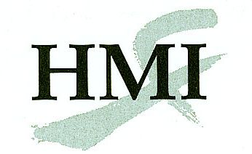
Chinese Scalp Acupuncture - Course Application
Chicago (Rosemont), IL
25 August 2018

Complete this form onscreen, then print and return it by mail or fax to:

Helms Medical Institute
2520 Milvia Street
Berkeley, CA 94704
Fax: 510-649-8692

The fee for this course is $725 through August 1st and $750 August 2nd through 15th. If you are taking both this course and the Graduate Refresher course, the fee is $1050 through August 1st and $1100 August 2nd through 15th.

Name:
First Initial Last

Degree:
MD, DO, DDS, DPM, DMD

State Medical License #:

Specialty:

E-mail:

Street:
Street address only, no P.O. boxes

City:

State: |  | Zip:_

Day Phone:

Home Phone:

Cell Phone:

Fax:
Please use the format 555-555-5555.

Year completed the MAFP Course:

Payment:
Make your check payable to Helms Medical Institute. If paying by credit card, provide this information or use this link: https://squareup.com/market/hmi

Card Number:
Discover, MasterCard, or Visa only.
Expiration Date: |  | /
Month Year

Cardholder’s Name:

Authorizing Signature:

Date: |  | / |  | /

Month Day Year

All training activities will take place at the Edward Hotel Chicago (Rosemont, IL) where a group rate of $112 (plus 14% occupancy tax) has been arranged. Reservation information will be provided upon acceptance to the course.

For additional information concerning this program call 510-649-8488 or e-mail mafp@HMIeducation.com.

