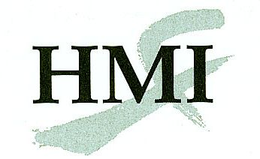
Chinese Scalp Acupuncture - Course Application
Boston, MA
5 November 2016

Complete this form onscreen, then print and return it by mail or fax to:

Helms Medical Institute
2520 Milvia Street
Berkeley, CA 94704
Fax: 510-649-8692

The fee for this course is $600 through 20 October 2016 and $650 beginning 21 October.

Name:
First Initial Last

Degree:
MD, DO, DDS, DPM, DMD

State Medical License #:

Specialty:

E-mail:

Street:
Street address only, no P.O. boxes

City:

State: |  | Zip:_

Day Phone:

Home Phone:

Cell Phone:

Fax:
Please use the format 555-555-5555.

Year completed basic HMI Course:

Payment:
If paying with a check, make it payable to Helms Medical Institute.

Card Number:
Discover, MasterCard, or Visa only.
Expiration Date: |  | /
Month Year

Cardholder’s Name:

Authorizing Signature:

Date: |  | / |  | /

Month Day Year

All training activities will take place at The Embassy Suites Boston by Hilton at Logan Airport where a group rate of $189 (plus taxes) has been arranged. Reservation information will be provided upon acceptance to the course.

For additional information concerning this program call 510-649-8488 or e-mail mafp@HMIeducation.com. Please apply early as the number of participants is limited.

