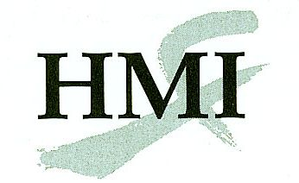
Medical Acupuncture for Physicians Application Form
AC 58
Tempe Mission Palms, Tempe, AZ
Introductory Weekend: 3 - 7 December 2015
Clinical I: 12 - 16 February 2016
Clinical II: 25 - 29 May 2016
Complete this form onscreen and print it. Return it with all the required documents by mail OR fax to: Helms Medical Institute
2520 Milvia Street
Berkeley, CA 94704
Fax: 510-649-8692
The following documents are required to process your application:
- Completed application form
- Résumé / CV
- Photocopy or scan of current medical license
- Statement of plans (Military applicants: In your statement, please confirm your base command's endorsement of your training and an acupuncture-friendly clinical setting.)
Name:
First Initial Last

Sex: Female Male

DOB: |  | / |  | /
Month Day Year

Degree:
MD, DO, other

State Issuing Medical License:

Medical License #:

Specialty:

Home E-mail: |  |  | Preferred

Work E-mail: |  |  | Preferred

Street:
Street address only, no P.O. boxes

City:

State: |  | Zip:_

Work Phone:

Home Phone:

Cell Phone:

Fax:
Please use the format 555-555-5555.

Military applicants only:
Service Branch:
Rank:

Date of end of obligated service: |  | /

mm yy

Pathway (choose one):
Pain Management Primary Care

Tuition:
300-hour CME course: $11,000 ($11,500 after 30 October 2015)
Full-time Resident or Fellow: $9,000 ($9,300 after 30 October 2015)
Note: You must be a full-time resident or fellow through the conclusion of the course.

Payment:
Make check payable to Helms Medical Institute. Mail or fax if using credit card. DO NOT SENT BY EMAIL.

Card Number:
Discover, MasterCard, or Visa only. No spaces.
Exp. Date: |  | /
mm yy

Cardholder’s Name:

Authorizing Signature:

You are requested to lodge at Tempe Mission Palms where a group rate has been arranged. A conference fee of $75 per day is required of participants who choose to stay elsewhere or room with another course participant. For additional information, call 510–649–8488 or e-mail MAFP@HMIeducation.com.

