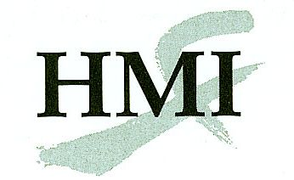
Medical Acupuncture for Physicians
Returning Warrior Application
AC 55 RW
Bolger Center, Potomac, Maryland
Introductory Unit: 24 - 28 April 2014
Clinical Unit 1: 11 - 15 July 2014
Clinical Unit 2: 8 - 12 October 2014

Complete this form onscreen, then print and send it with all the required documents by mail or fax to:

Helms Medical Institute
2520 Milvia Street
Berkeley, CA 94704
Fax: 510-649-8692
E-mail: mafp@hmieducation.com

The following documents are required to process your application:
- Completed application form
- Photocopy or scan of current medical license
- Recent photograph

Select the session(s) you wish to attend:
Tuition $1000:
Introductory session (24-28 April 2014)
Tuition $2000 per session:
Clinical Unit 1 (11-15 July 2014)
Clinical Unit 2 (8-12 October 2014)

Name:
First Initial Last

Degree:
MD, DO, other

State Medical License #:

Specialty:

E-mail:

Street:
Street address only, no P.O. boxes

City:

State: |  | Zip:_

Day Phone:

Home Phone:

Cell Phone:

Fax:
Please use the format 555-555-5555.

Year you completed the basic HMI course:

Payment: If paying with a check, make it payable to Helms Medical Institute.

Card Number:
Discover, MasterCard, or Visa only.
Expiration: |  | /
Month Year

Cardholder’s Name:

Authorizing Signature:

Date: |  | / |  | /

Month Day Year

All training activities will take place at the Bolger Conference Center, Potomac, Maryland, 45 minutes from Reagan or Dulles International Airports. You are requested to lodge at the hotel where group rates have been arranged. A conference day use fee of $75 per day is required of participants who choose to stay elsewhere or who share a room with another course participant. For additional information concerning this program call 510-649-8488 or e-mail mafp@hmieducation.com. There are a limited number of available positions for Returning Warriors.

